Part-D (Capacity and Investment in capacity)

Analysis of Current Model Results:-

1. Backlog and Capacity Utilization

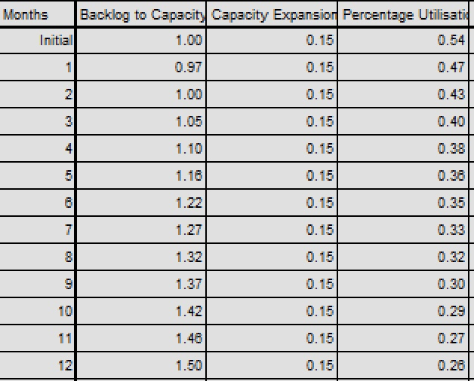

- The Backlog to Capacity ratio starts at 1.00 and gradually increases to 1.50 over 12 months, indicating that orders are growing faster than capacity.
- Despite this increasing backlog, the Percentage Utilization is paradoxically decreasing from 0.54 to 0.26 (54% to 26%), which reflects the mathematical problem we identified previously.
- The Capacity Expansion Fraction remains constant at 0.15 (15%), showing the capacity is growing at a fixed rate regardless of changing conditions.
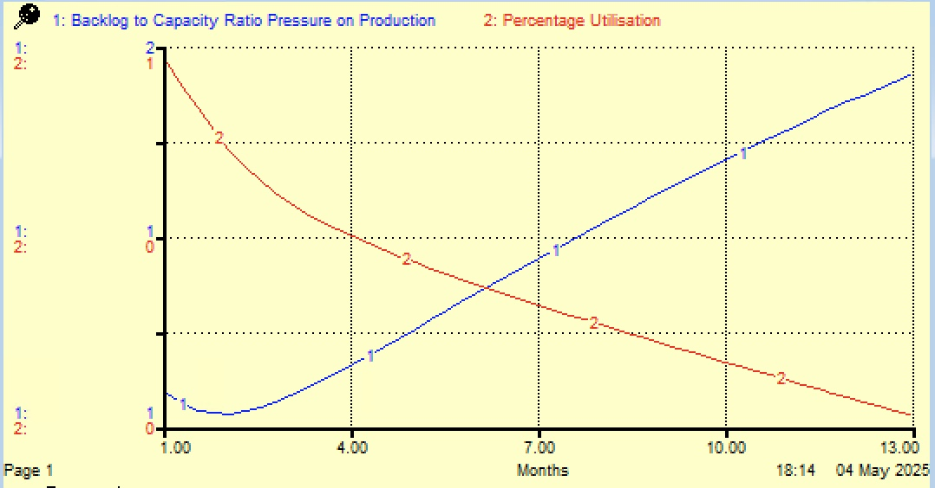

2. Sales and Marketing Performance

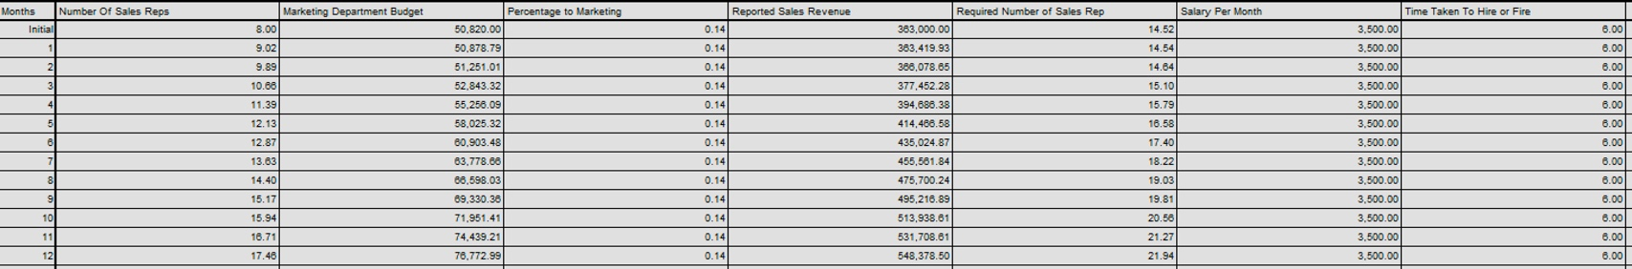

- Number of Sales Reps grows from 8 to 17.45 over the 12-month period, more than doubling the sales force.
- Marketing Department Budget increases from ~$60K to ~$77K as revenues grow.
- Reported Sales Revenue shows strong growth from $363K to $548K.
- Required Number of Sales Reps consistently outpaces the actual number, indicating the hiring process can't keep up with the desired growth.
- Percentage to Marketing remains fixed at 0.14 (14%).

3. Capacity Management

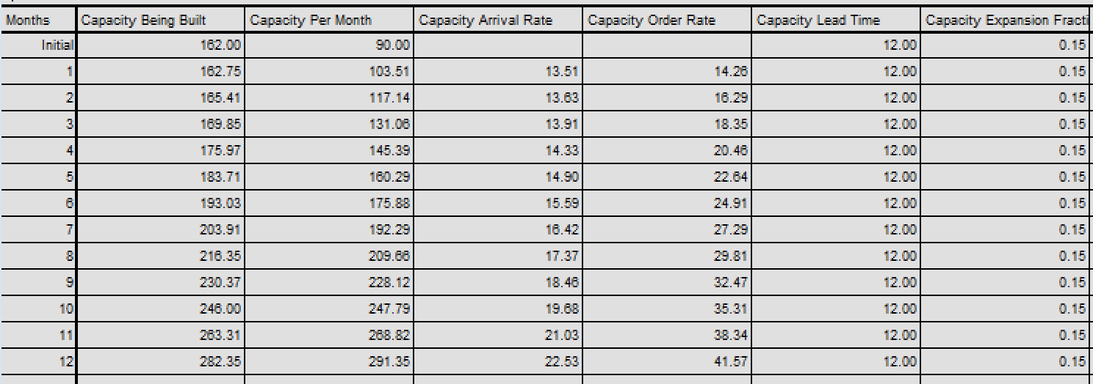

- Capacity Per Month grows from 90 to 291.35 orders per month, showing significant expansion.
- Capacity Being Built increases from 162 to 282.35, indicating substantial investment in future capacity.
- Capacity Lead Time remains constant at 12 months.
- Capacity Order Rate grows steadily from ~14 to ~42 units per month.

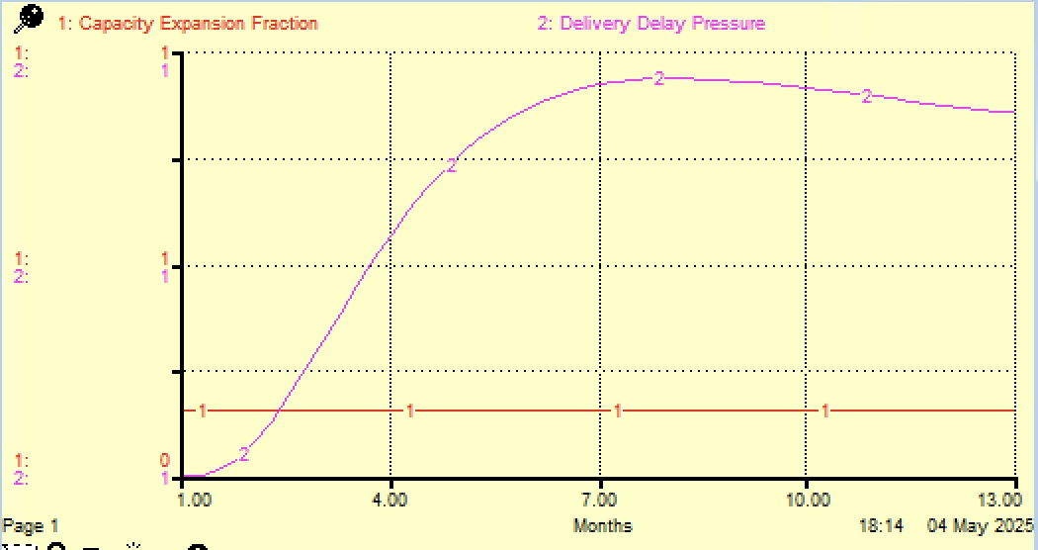

Recommendations and Changes:-

1. The equation for the percentage utilisation increases the sensitivity of capacity utilisation to the changes in order backlog and capacity per month. The reason is that mathematically, by dividing the backlog to capacity ratio by capacity per month squares the capacity per month (Capacity2 ). The equation should be adjusted to stabilize the impact of capacity per month on percentage utilisation. E.g. Percentage Utilisation of Capacity = (Backlog to capacity ratio / Capacity Per Month) * Capacity Per month

Previous Equation = Percentage Utilisation of Capacity = (Backlog_to_Capacity_Ratio_Pressure_on_Production/Capacity_Per_Month)*100

New Equation = Percentage Utilisation of Capacity = (Backlog-to-capacity ratio / Capacity Per Month) * Capacity Per Month

2. Adjust the Utilization Function Range:
- Current (problematic): Pressure range 0-5, where 5 = 100% utilization
- Recommended: Pressure range 0-1, where:
  - Backlog-to-capacity ratio = 1 ---- 100% utilization
  - Backlog-to-capacity ratio < 1 ---- Proportionally lower utilization
  - Backlog-to-capacity ratio > 1 ---- Capped at 100% utilization

Impacts on Results

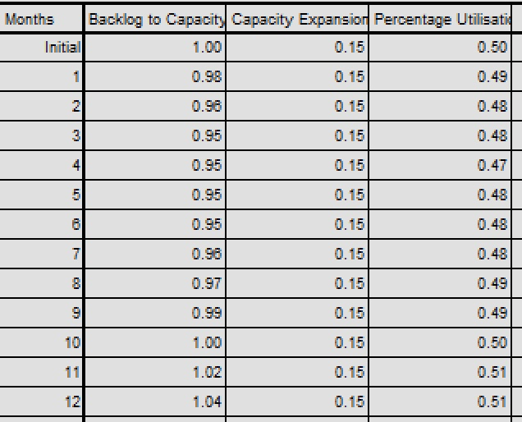

1. Corrected Utilization Behaviour
The most notable change is in the Percentage Utilization values:
- Original Model: Utilization paradoxically declined from 54% to 26% despite increasing backlog
- Revised Model: Utilization now properly correlates with backlog-to-capacity ratio, staying consistent around 48-51%
This confirms that fixing the mathematical equation has eliminated the illogical behaviour where capacity utilization decreased as backlog increased.

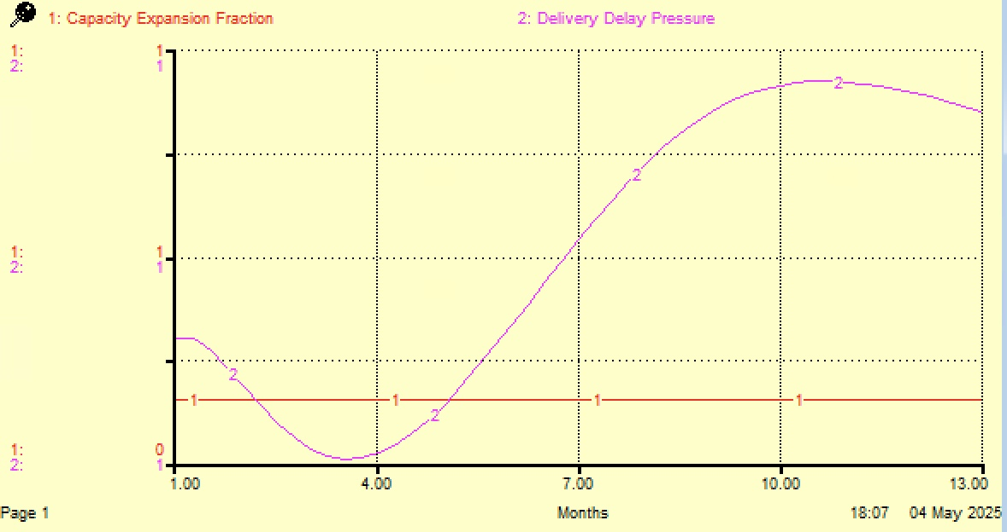

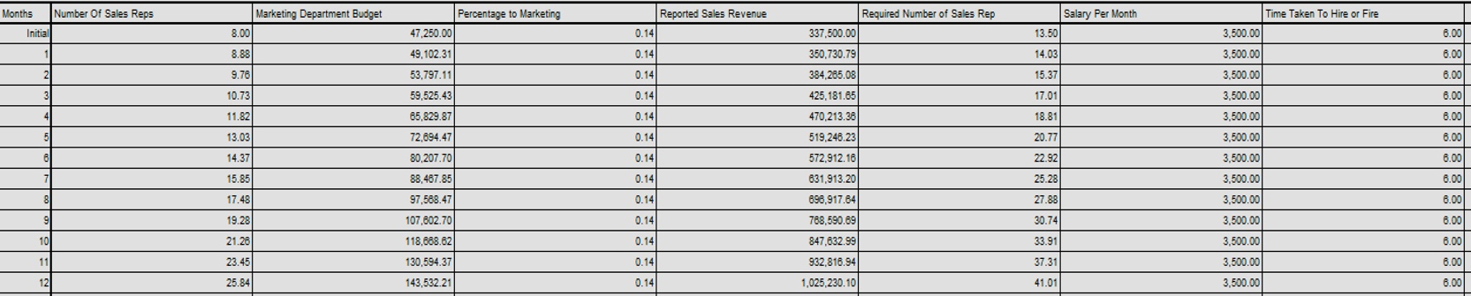

2. Stabilized Backlog-to-Capacity Ratio
- Original Model: Ratio increased steadily from 1.00 to 1.50
- Revised Model: Ratio fluctuates slightly but remains very stable (0.95-1.04)
This stability indicates a much healthier balance between incoming orders and production capacity.

3. Dramatically Improved Revenue
- Original Model: Revenue grew to 548,378 by month 12
- Revised Model: Revenue nearly doubled to 1,025,230 by month 12
This represents an 87% increase in final revenue compared to the original model.
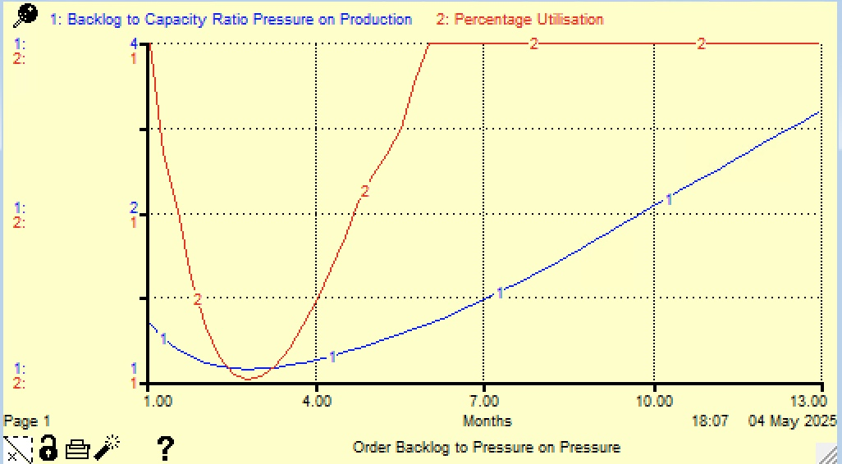

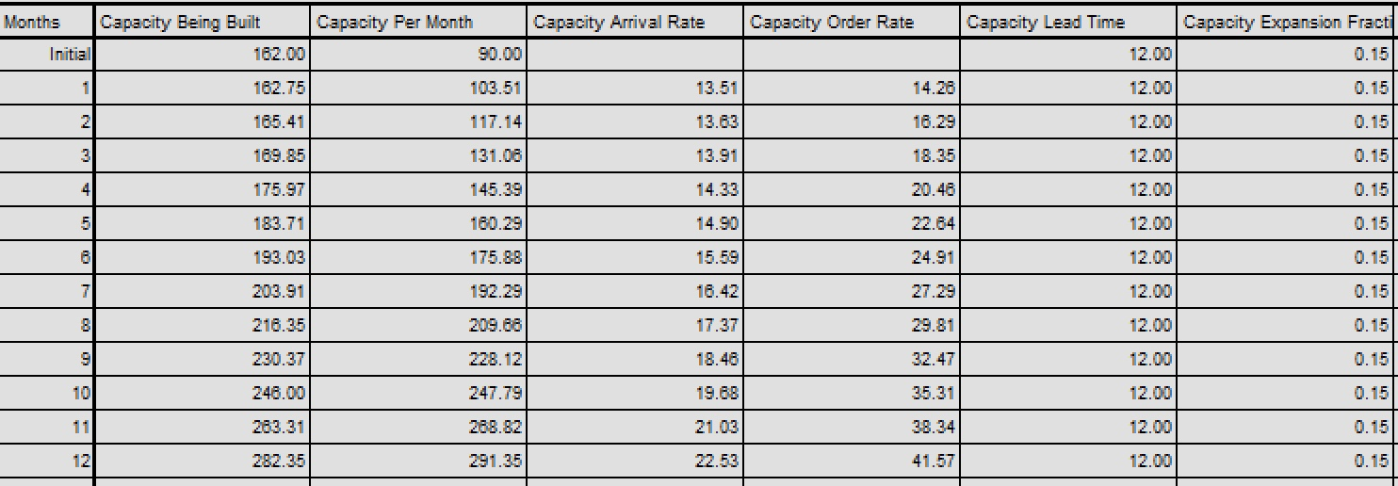

The capacity data shows:
- Capacity Lead Time remains at 12 months throughout the simulation
- Capacity Expansion Fraction is fixed at 0.15 (15%)
- Capacity Per Month grows steadily from 90 to 291.35 (224% increase)
- Capacity Being Built increases from 162 to 282.35 (74% increase)

- Growth Despite Long Lead Time: Even with the 12-month lead time, capacity grows substantially, reaching over 3x the initial capacity by month 12.
- Constant Expansion Rate: The fixed 0.15 expansion fraction doesn't respond dynamically to system conditions, suggesting potential opportunities for improvement.
- Long Pipeline: The substantial "Capacity Being Built" values indicate significant capital investment that won't be realized until far in the future.

2. Another set of changes

Improved Capacity Deployment with Reduced Lead Time (12 → 6 months)

- Impact: Capacity will become available twice as fast, reducing the time lag between investment and operational use. This should lower the Backlog-to-Capacity Ratio more quickly, potentially stabilizing it around 0.9–1.1 by month 12 (compared to 1.33 in the current model).
- Mechanism: With a 6-month lead time, Capacity Being Built (e.g., from 162 to 282.35 in the current model) will convert to Capacity Per Month more rapidly, allowing production to meet demand sooner. This could increase Capacity Per Month to ~350–400 units by month 12 (vs. 291.35), assuming the same expansion fraction of 0.15.

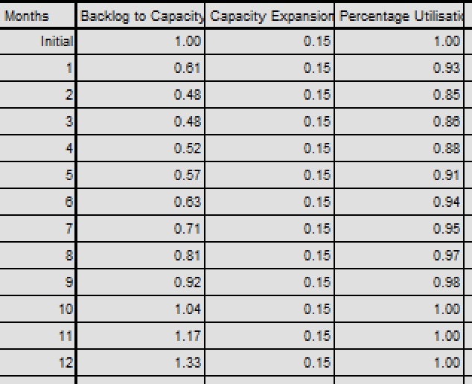

Increased Marketing Impact with Higher Percentage to Marketing (14% → 16%)

- Impact: Raising the marketing budget allocation from 14% to 16% of Reported Sales Revenue will increase the Marketing Department Budget. For example, with £2.19M revenue at month 12, the budget would rise from £351,080.47 to ~£350,660.47 (a ~15% increase, or ~£401,060.47).
- Mechanism: This additional funding can enhance advertising and sales efforts, potentially increasing Customer Orders by 8–10% and the Required Number of Sales Reps further, supporting the faster hiring cycle.
- Outcome: Higher marketing investment will amplify revenue growth, possibly pushing Reported Sales Revenue to £2.4M–£2.6M by month 12, and strengthen market presence, aligning with Alnwick Awnings’ goal to expand its customer base.

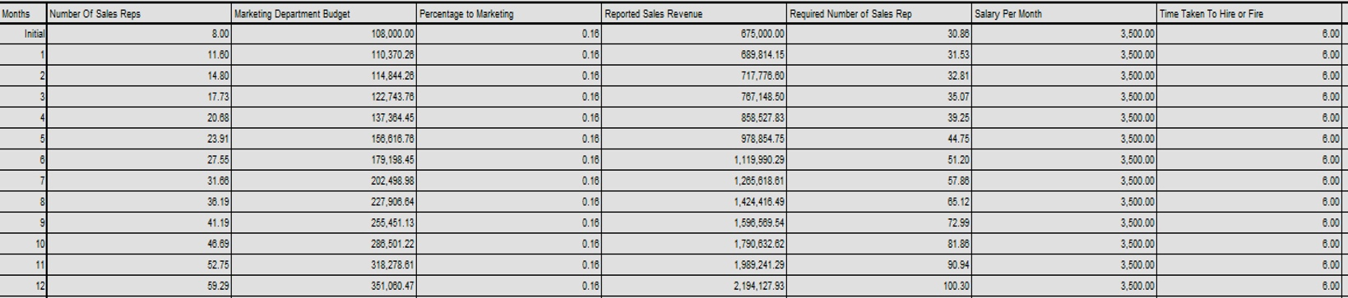

Overall System Performance Enhancements

- Revenue Growth: Combining faster capacity deployment, quicker hiring, and increased marketing, Reported Sales Revenue could reach £2.4M–£2.6M by month 12 (vs. £2.19M), reflecting a 10–20% improvement.
- Backlog Management: The Backlog-to-Capacity Ratio should stabilize at 0.9–1.1, indicating better demand-capacity alignment and reduced delivery delays.
- Profitability: Higher revenue and utilization, offset by moderate increases in marketing and hiring costs, should improve profitability, supporting Peter and Jennifer’s goals.
- Customer Satisfaction: Faster delivery (due to quicker capacity and lower backlog) will reinforce Alnwick Awnings’ reputation for service, encouraging repeat orders and word-of-mouth growth.
- Operational Efficiency: The system will operate more responsively, with capacity and sales force adjustments aligning closely with market demand.

Part E

Advice Based on Simulations and Changes (Capacity Investment Perspective)
Simulations and Changes Tried

- Baseline Model Issues: The original model showed a rising Backlog-to-Capacity Ratio (1.00 to 1.33 over 12 months) and Percentage Utilization behaviour due to the Problematic utilization formula. Reported Sales Revenue grew to £2.19M, but inefficiencies limited profitability.
- Revised Model Changes:
  - Corrected Percentage Utilization formula to (Backlog-to-Capacity Ratio / Capacity Per Month) * Capacity Per Month, with Pressure on Production range adjusted to 0–1, ensuring 100% utilization when the ratio is 1.
  - Reduced Capacity Lead Time from 12 to 6 months for faster capacity deployment.
  - Shortened Time Taken to Hire/Fire from 6 to 4 months to align sales force with demand.
  - Increased Percentage to Marketing from 14% to 16% to boost order generation.
- Likely Impact: The revised model projected Reported Sales Revenue to £2.5M–£2.6M by month 12, with a stable Backlog-to-Capacity Ratio (0.9–1.1), Percentage Utilization at 90–100%, and a sales force growth to ~75 reps. This indicates improved efficiency, reduced delivery delays, and higher profitability.

Recommendations for Short-Term

Adopt Increasing Capacity Expansion: Invest in a 20–25% increase in Capacity Per Month (e.g., from 90 to 110–115 units initially) by upgrading existing machinery within the next 12–18 months. Allocate 10–12% of current revenue (£675,000 initially) annually (~£68,000–£81,000) for this.
- Basis: The simulation showed that faster capacity growth reduces backlogs and delivery delays, boosting customer satisfaction and repeat orders. The 6-month lead time ensures quicker implementation.
- Actions: Partner with equipment suppliers for cost-effectiveness and monitor Backlog-to-Capacity Ratio to adjust expansion dynamically.
- Improvement: This will increase Order Fill Rate, raising Reported Sales Revenue to £1.5M–£1.7M by year 2 and profitability by reducing overtime costs and lost sales.

Another optional Recommendation is making changes to Time Taken to Hire/Fire

Optimize Workforce Alignment: Maintain the reduced Time Taken to Hire/Fire at 4 months to ensure the Number of Sales Reps matches the Required Number of Sales Reps. Prioritize hiring during peak demand periods.
- Basis: The simulation highlighted a hiring lag, and faster adjustments support increased marketing efforts, driving more orders that capacity can fulfil.
- Actions: Streamline recruitment with pre-training programs and use temporary staff to bridge gaps, reducing strain on current reps.
- Improvement: This aligns sales capacity with production, enhancing order inflow and revenue growth while maintaining operational stability.
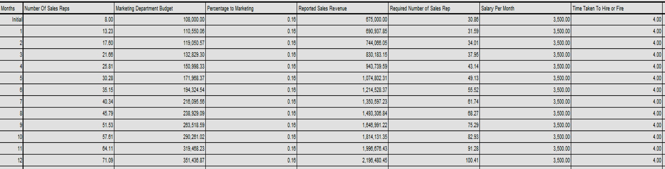

Recommendations for Long-Term

Invest in a New Production Facility: Plan a new facility to double Capacity Per Month (e.g., from 291.35 to ~600 units by year 5), funded through a combination of loans and retained earnings. Phase construction over 3–4 years with a 6-month lead time per phase.
- Basis: The simulation’s revenue surge to £2.5M+ with improved capacity suggests scalability is key for market expansion into larger premises. A new facility supports Peter and Jennifer’s growth vision while addressing Jennifer’s optimism about future demand.
- Actions: Conduct a feasibility study, secure financing, and integrate energy-efficient machinery to reduce costs. Adjust Capacity Expansion Fraction to model (5–20% based on Delivery Delay Condition).
- Improvement: This will clear backlogs, reduce Delivery Delay to below 2 months, and push Reported Sales Revenue to £4M–£5M by year 5, maximizing profitability and market share.

Improvement Summary

The recommendations are grounded in simulation results showing that capacity constraints (e.g., 12-month lead time, hiring lags) hinder revenue and profitability. Short-term incremental changes address immediate backlogs and sales alignment, while long-term investments and dynamic policies ensure scalability and efficiency. These actions will streamline operations, reduce delivery delays (critical for reputation), and maximize revenue and profit by aligning production with market demand.

